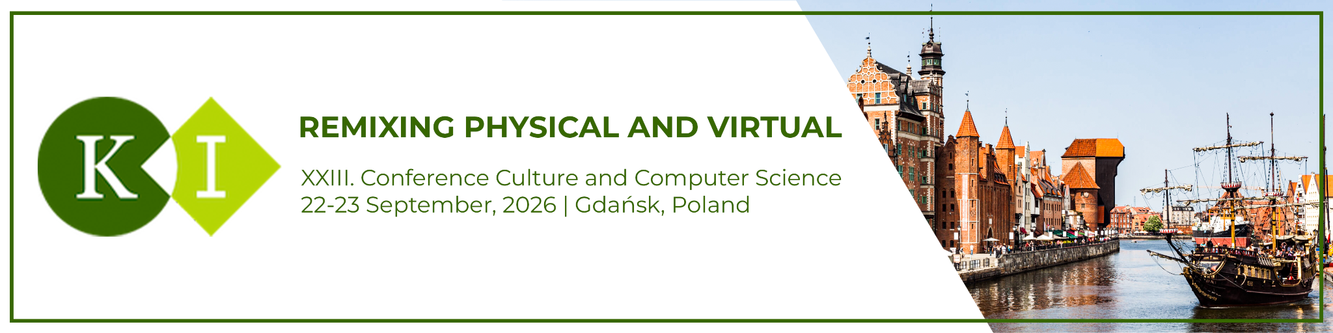
Demo and Artistic Project submission

- Contact details
First Name |  | Last Name
Date of Birth |  | Nationality
Country of Residence |  | Affiliation (optional)
Address
Telephone No. |  | Mobile
Email |  | Website

- Project details
Original title
English title
Production year / span

- Thematic description (300–800 words)
Give a short overview of the project's topic / research and an insight into the technical realization of the project.

- Technical and logistical requirements
Please describe exactly everything necessary to run and display the demo (e.g., one external monitor, two headsets, one table, etc.). Please indicate which equipment you will bring and what you would need from us. We provide a basic set of table, electricity and Wi-Fi, but are happy to support with additional requirements if possible.

- Images, sketches, drafts

- Links to video documentation and additional weblinks (optional)

